ATIVIDADE DE CLASSE

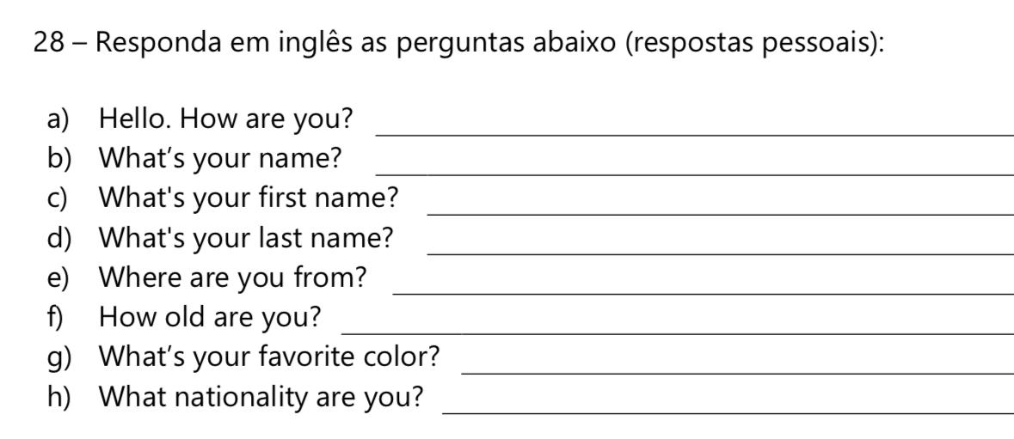

1. I’M GOOD
2. MY NAME’S MORGANA.
3. MY FIRST NAME’S MORGANA.
4. MY LAST NAME’S IS SOUZA
5. I’M FROM BRAZIL
6. I’M 21 YEARS OLD.
7. MY FAVORITE´S BLACK.
8. I’M BRAZILIAN

ALUNA: MORGANA SOUZA

TURMA: TADHS036

TURNO: MANHÃ